|  |
| --- |
| IAM RoadSmart  Group Organised Rides Manual of Guidance |
|  |
|  |



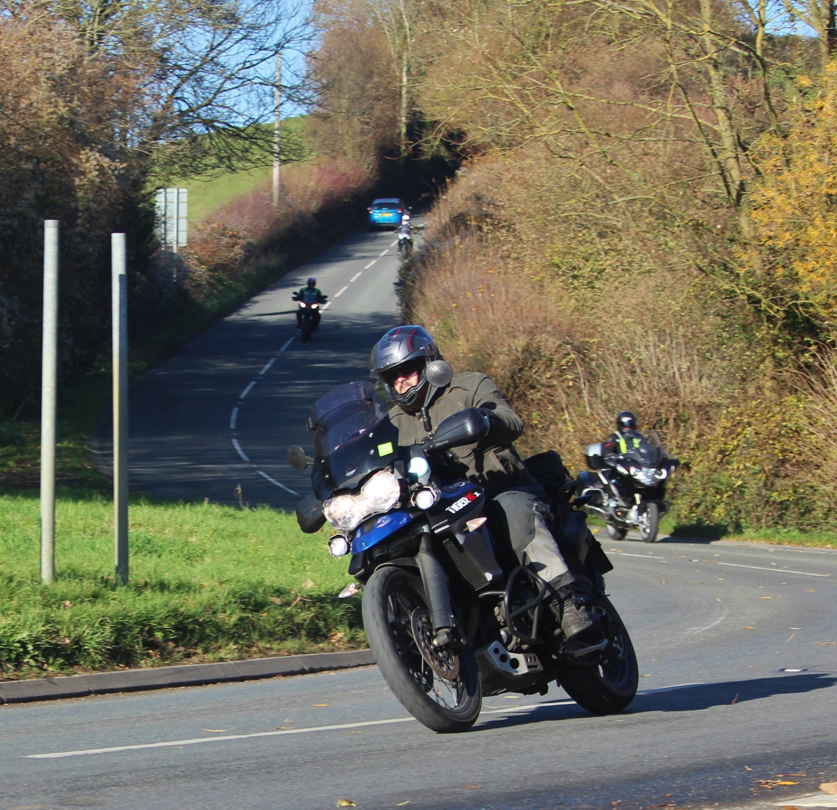

|  |
| --- |
|  |
|  |
|  |

**Contents**

1. Introduction
2. A standard approach
3. Safety
4. The law
5. Definition of a group ride
6. Associate guide
7. Rider ability
8. Planning the ride
9. Publicity
10. Size of group
11. Lead and tail-end rider basic principles
12. The briefing prior to setting off
13. On the road
14. The leader's role
15. When behind the leader
16. When you are the marker
17. Tail-end rider
18. If you get lost

# Introduction

When motorcyclists meet, they often choose to ride together as a group. Riding with a group of bikes can be great fun but riding safely with others requires a degree of discipline – and sometimes restraint too – if everyone is going to enjoy the experience. These guidelines describe a series of techniques that will assist groups of riders to enjoy their riding together in such a way that safety is maximised, without affecting enjoyment.

# A standard approach

The advantage of using a standard approach to riding in a group is that all riders will know what is expected of them and understand what other riders in the group are likely to do, and what is expected of them while they are riding. It follows that this improves the chances of all members of the riding group reaching the required destination without getting lost and in the safest way possible. It also means that, should a rider take a wrong turn, for example, they and the rest of the group have a method of locating each other again.

# Safety

The paramount consideration when riding in a group is always safety. At no time should the safety of riders, or any third party be compromised. Whilst these guidelines should result in the elimination of undue risk for most circumstances, it always remains the personal responsibility of all riders within the group to exercise their own judgement about every course of action that they take. Each rider is responsible for their safety, actions, and any consequences that those actions may have.

# The law

Traffic laws must always be obeyed when riding on the road. Do not worry if you fall behind, there will be a marker rider waiting to show you the route. Ride your normal ride within your capabilities and don’t be tempted to change this.

# Definition of a group ride

The insurance policies cover four specific types of group ride.

|  |  |  |  |
| --- | --- | --- | --- |
| Type of ride | Eligible participants | Training | Details & Cover Provided |
| 1. Social ride out | Full Members  Associate members  Non-members | No | A social ride with no formal training or observing element included.  IAM RoadSmart group ride guidelines are considered good practice.  **Full & Associate Members**  Public Liability Insurance applies  Trustees (Group Officials) Indemnity Insurance does not apply.  IAM RoadSmart observer insurance does not apply  **Non-Members**  Public Liability Insurance does not apply  Trustees (Group Officials) Indemnity Insurance does not apply.  IAM RoadSmart observer insurance does not apply. |
| 1. Social ride out | Full members | No | A social ride with no formal training or observing element included.  IAM RoadSmart group ride guidelines are considered good practice.  **All Participants**  IAM RoadSmart observer insurance does not apply.  Public Liability Insurance applies as a group organised activity.  Trustees (Group Officials) Indemnity Insurance applies. |
| 1. All members Group ride | Group full members  Group associate members  Prospective associates | Yes | An officially organised ride for full and associate members and prospective associates.  Briefing from ride leader and tail-end rider. Coaching available on an ad-hoc basis from observers within the group. Associates must be under observation.  Prospective associates must have had an individual assessment before attending and be under observation.  IAM RoadSmart group ride guidelines are to be followed.  **All Participants**  IAM RoadSmart observer insurance applies.  Public Liability Insurance applies as a group organised activity.  Trustees (Group Officials) Indemnity Insurance applies. |

|  |  |  |  |
| --- | --- | --- | --- |
| 1. Group training ride | Group full members  Group associate members | Yes | An officially organised training ride for members of IAM RoadSmart, formally arranged through the observer network.  These rides may be categorised for full members or observers only and can have associates present for training purposes.  If associates are present, there must be an associate to observer ratio of no more than 3 to 1, and the associates are to be under guidance during the ride.  No prospective associates should be on this group training ride.  IAM RoadSmart group ride guidelines are to be followed.  **All Participants**  IAM RoadSmart observer insurance applies.  Public Liability Insurance applies as a group organised activity.  Trustees (Group Officials) Indemnity Insurance applies. |

# Observer to associate guidance

This section is intended to apply ONLY when the associates are receiving a guidance ride and where the observer will be giving a full briefing/debriefing.

The ratio of associates to observers on a group organised ride should not exceed 3:1, and ideally should be no more than 2:1. Groupings may be arranged directly between the associates and observers OR the group could arrange a set venue/start point where associates are allocated to observers.

# Rider ability

Every rider must ride within their capabilities and exercise judgement when determining the safety of their actions. If at any time a rider feels that they are not capable of continuing, as the ride exceeds their skill level, then they should pull over at a safe and legal position until they are joined by the tail-end rider, who will consider appropriate options to take, which may include:

Organising 1:1 guidance for the rider separately from the group ride.

Adjusting the pace of the ride.

Agreeing that the rider should ride separate from the group.

# Planning the ride

The organiser should decide the purpose of the ride and the capabilities of the members who will participate. If either of these factors subsequently changes, the organiser should re-plan the event accordingly.

The ride plan should consider the distance to be covered, types of roads, fuel range of machines, breaks etc. No on-road section between breaks/debriefs should be planned to exceed 90 minutes.

The group should ensure that suitable full members are appointed as the ride-leader and if there is an element of training/coaching a qualified observer as tail-end rider as a minimum. Groups should consider providing ride leader and tail-end rider training courses. For more information contact your Area Service Delivery Manager who can recommend groups running successful courses. All riders associated with the running of the group ride should be fully conversant with this manual of guidance regarding IAM RoadSmart policy and advice.

# Publicity

Group organised rides should be advertised within the group’s usual communications channels. These channels should include a reminder that participants in group organised rides are responsible for their safety and compliance with the law and should always ride within their capabilities.

# Size of group

Be aware that large groups of motorcycles riding together can disrupt the flow of traffic and should be avoided.

Where the number of participants is large, riders are of mixed ability, the route complexity or required skill level justifies it, consideration should be given to splitting the run into smaller groups.

# Lead and tail-end rider basic principles

Riding in convoy and stopping on the road to allow riders to regroup are two practices that should be avoided when riding in a group and a well-established method exists that makes both unnecessary. This is the leader and tail-end rider system.

The basis of the system is that the leader (usually the ride organiser) stays at the front of the group and the tail-end rider remains at the rear as the names suggest. Whilst not compulsory and depending on distance, communication via radio/Bluetooth/mobile phone can greatly assist both the leader and tail-end rider.

Whenever there is a deviation from the obvious straight-ahead route, the rider travelling behind the leader pulls over in a visible, safe and legal position to point all bikes in the correct direction. This bike is called the marker and when the tail-end rider comes along the marker re-joins the route in front of the tail-end rider. As the journey continues each rider will, in turn, become the rider behind the leader, and therefore become a marker before re-joining in front of the tail-end rider.

By following this basic system every rider regardless of ability within the group may ride their own ride, without the need to maintain a pace they are not comfortable with and without the risk of getting lost. There is never a need to ride in convoy with all bikes in sight of each other.

# The briefing before setting off

* Remind all riders that they are responsible for maintaining safety and complying with the law at all times.
* Make sure that everyone is familiar with the lead & tail-end rider system. If the group is large, consider riding in two or more separate groups.
* All riders should be made aware who the lead and tail-end riders are and how they can be identified on the road.
* Ensure every rider knows how to recognise the leader’s signal to stop and act as a marker.
* Every rider doesn’t need to have full route details, but it may be beneficial that all are aware of the rest stops and final destination.
* Ensure that everyone is aware of the number of bikes within the group and who are riding together .
* Remind participants that if any rider is planning to leave the group other than at a pre-arranged stop, they should inform the lead or tail-end rider of their intentions.
* Although no rider is expected to become separated from the group, it may be advisable to have a plan.
* If this is a training ride the IAM RoadSmart disclaimer should be given to the associate by the observer before commencing the ride.

Suggestions:

Agree a rendezvous point and time.

All riders should have the mobile phone numbers of the lead and tail-end rider.

# On the road

* Remember- Safety first!
* At all times, every rider is responsible for their own safety, their actions and any consequences that those actions may have.
* The leader is responsible for navigation only, every rider must use their judgement about every course of action that they take.
* Always obey traffic laws.
* Ride at a pace that is legal and at no time ride faster than you consider safe for the conditions, always ride smoothly and predictably, try to avoid harsh acceleration, sudden braking or changes in direction.
* At junctions take the obvious straight-ahead route unless a marker bike indicates otherwise.
* At roundabouts, the marker bike should be on the exit route, if you cannot see the marker on the approach be prepared to circle the roundabout to confirm the correct exit (mainly large roundabouts).
* Overtaking within the group should be facilitated where safe and legal. A rider should not be pressured into going any faster than they feel safe and the following rider should not pressure the rider in front. The following rider can make their intentions known and where appropriate the rider in front can yield allowing for a safe and courteous overtake. The tail-end rider will not overtake others in the group.
* If you intend to leave the group, allow all riders pass you and indicate to the tail-end rider your intentions. Preferably this will have been communicated at the briefing stage if possible, however circumstances may change during the ride.
* When on the open road, ride in staggered formation when near other group riders.
* Allow other road users to overtake the group if they wish. Where it is safe make space for them to do so.

# The leader’s role

* Plan a route that will be achievable for the abilities of the expected riders, with suitable refreshment stops and refuelling opportunities.
* Brief all riders before setting off (see 12 above)
* Ride smoothly and at a steady pace.
* If you do not have a bike behind you to act as a marker for a change in direction, stop in a safe place or slow down until one arrives.
* Unless there is a deviation from the obvious straight-ahead route, you do not need to mark the junction except at roundabouts when the exit should always be marked.
* Always leave a marker at a change in direction even if you think all the group are in sight of each other.
* The ultimate responsibility for the safety of markers is their own, but you can help them mark the route effectively and safely by giving them plenty of warning that you require them to stop.
* If it becomes apparent that the Group has come to a halt because a rider has had problems, consider retracing the route until you discover the cause of the hold-up and take appropriate action. Ensure that those who have stopped beyond the hold-up are kept informed of the situation.
* If in the opinion of the ride leader, any participant who through their attitude or actions, endangers others within the group ride, or members of the public, or whose riding would bring IAM RoadSmart into disrepute, should be advised by the ride leader to rectify their riding immediately or be excluded from continuing within the group ride. If any rider is excluded a report must be created detailing the incident and is to be submitted by the ride leader to the group committee.

# When behind the leader

Be prepared to stop and act as the marker when indicated to do so by the ride leader, however, if you are the second bike behind the leader and you realise that the bike in front has not marked a change in direction when indicated to do so by the leader, then mark it yourself.

# When you are the marker

Never compromise your personal safety or the safety of others by stopping in a dangerous location. No one in the group wants to get lost, but that is preferable to putting yourself at risk. When the leader signals for you to stop, do so only where you are safe and visible to the following riders. It is your decision where to stop but remember that to be an effective marker you need to be visible to the following bikes and point out the direction to follow. Do not move until the tail-end rider appears. If the tail-end rider fails to appear, do not move. If something has gone wrong, someone will return for you. REMEMBER - you are all that’s going to help the following bikes find the correct route. If you see other riders from the group take the wrong direction do not attempt to chase after them. Wait until the tail-end rider arrives and inform them. If the riders return in the meantime, then you don’t need to inform the tail-end rider if you are sure that all riders that took the wrong direction have returned to the junction you are marking. Make sure that what appears to be the last bike is really the tail-end rider who will slow down as they approach to enable you to pull out safely in front.

Always remain on your machine and be ready to move off.

# The tail-end rider

* As you approach the marker bike slow down to enable the rider to pull out. If it is necessary to stop and wait, then do so in a safe place. Try not to pass the marker as this is how they will know you are the tail-end rider.
* Watch for any rider who feels that the pace is too quick and is signalling for other bikes to overtake Allow such a rider to stay at the rear of the group in front of you. Such riders should be observed and not encouraged to ride faster.
* Keep an eye out for riders in front of you that are clearly riding inappropriately or may be struggling. In conjunction with the leader, identify appropriate actions to address the situation.
* Watch for any bikes that have pulled over for any reason, if safe stop to find out what the problem is.

# If you get lost

The most common cause of getting lost is a failure to see a marker or someone leaving the group while on the road and the bike behind follows. These are avoidable if everyone follows this guide.

If you arrive at a junction and there is no marker it is likely that you have made an incorrect turn. Retrace your route to the last place you saw a marker where the tail-end rider may be waiting for you. Note that the tail-end rider will wait 10 minutes and then proceed on the route, so as not to hold up the ride.

# Acknowledgements

Revised with the generous assistance from:

Jerry Rogers - Plymouth Advanced Motorcyclists

Mark Canning and Stephanie Evans - Herts & Beds Advanced Motorcyclists

Chris Brownlee - Thames Vale Advanced Motorcyclists

|  |
| --- |
|  |



|  |
| --- |
| 1, Albany Place  Hyde Way  Welwyn Garden City  AL7 3BT  0300 303 1134  Registered in England and Wales 562530  Registered charity number 249002 (England and Wales) SC041201 (Scotland)  www.iamroadsmart.com |