MELKSHAM & DISTRICT GROUP OF ADVANCED MOTORISTS

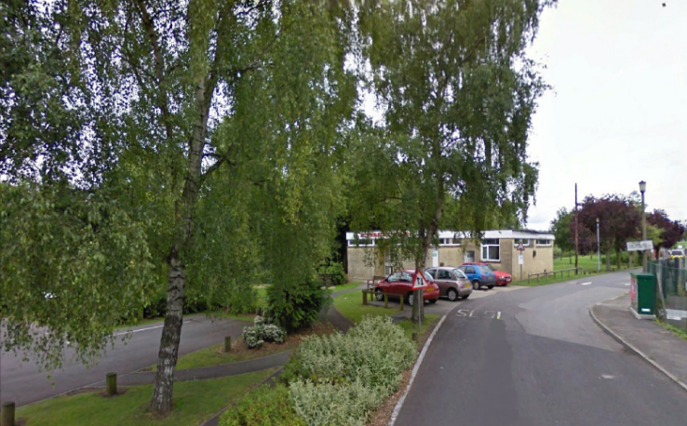 | Social Evenings  Our monthly Social Evenings feature a guest speaker or other event, chat, tea and raffle, and are held every 3rd Thursday of the month. They take place at 19:30 at the Riverside Club, Bath Road, Melksham, SN12 6LP, unless otherwise advised – if needed, there is a map on our Website. There is a modest charge of £1 to cover refreshments and a ticket for the raffle.  Bring a friend: All are welcome, including non-members and members of other groups.
The Riverside Club
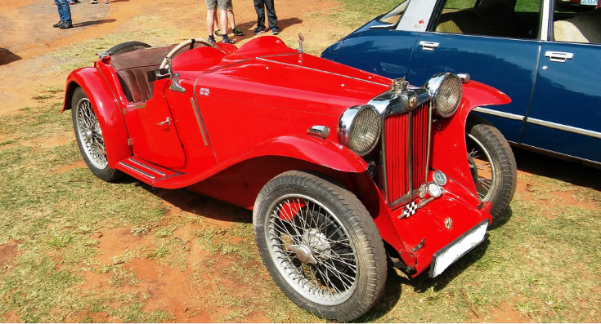
Classic British Cars
MG P-Type 1934-1936

COMING EVENTS (2019)

19:30 Thursday 16 May. Melksham Advanced Motorists Annual General Meeting. Please attend, and have your say on how the club is run. It’s your club! Also, there will be a talk by operators of the “Bobby Van”.

19:30 Thursday 20 June. Check drive evening. Come along and refresh your advanced driving with an allocated Observer.

19:30 Thursday 18 July. Skittles evening at the White Hart, Atworth. Come along, it’s always a good evening.

19:30 Friday 13 December. The MAM will be holding its Christmas dinner at the Barge Inn, Seend. Make sure you reserve your place/s early for this ever increasingly popular event.

NEWS ITEMS

Social Evening 19:30 Thursday 18 April.

A presentation was provided by members of the St John Ambulance organisation. The presenters explained that the St John Ambulance organisation is a charity whose work is underpinned by a long and diverse heritage. Their story goes all the way back to 11th century Jerusalem, where the first Knights of St John set up a hospital to care for sick pilgrims. The organisation was banned by Henry VIII when England separated from the Catholic church, but reformed as the St John Ambulance Brigade in 1887.

The presenters went on to explain that the St John Ambulance is the nation’s leading first aid charity. Their volunteers provide first aid in their communities, keeping people safe at events, and working alongside the NHS in response to 999 calls. They also campaign to raise awareness of first aid and directly educate the public.
A demonstration of the Heimlich Manoeuvre was provide, and the resuscitation procedure was explained.
The presentation, which was at times humorous, was well received by the audience.

ARTICLES

Driving Your Car Abroad After Brexit – What You Need to Know. Based on an Article by the Automobile Association (AA).

Did you know, the documents you need to carry when driving abroad may change after Brexit?

A no deal Brexit will mean that you’ll need a Green Card when driving your car abroad. It proves you have the minimum compulsory insurance cover to drive in the country you’re visiting.

Even if we leave the EU with a deal, you may still need a Green Card, so it’s recommended that you get one.

Where do I need a Green Card?

You already need a Green Card when driving in some countries. Here’s a list of the new ones where you may also need a Green Card after Brexit:

Andorra, Austria, Belgium, Bulgaria, Croatia, Czech Republic, Denmark, Estonia, Finland, France, Germany, Gibraltar, Greece, Hungary, Iceland, Ireland, Italy, Latvia, Liechtenstein, Lithuania, Luxembourg, Malta, Monaco, Netherlands, Norway, Poland, Portugal, Republic of Cyprus, Republic of Ireland, Romania, San Marino, Serbia, Slovak Republic, Slovenia, Spain, Sweden, Switzerland.

When do I need to get a Green Card?

- Driving abroad and returning on or before Brexit – you don’t need a Green Card.

- Driving abroad for all or part of your trip after Brexit – you do need a Green Card.

- Driving abroad after Brexit – you do need a Green Card.

We were planning for an EU exit on 29 March, however this date is now unknown.

How do I get a Green Card (if and when the time comes)?

Contact your insurance company.

Common Car Maintenance Myths. Based on an Article by Swinton Insurance.

There are so many car myths out there, so Swinton Insurance has attempted to bust some of them:
You must change your engine oil every 3000 miles.
Whilst this may have been a good recommendation years ago, most modern cars driven under normal conditions can go 7500 miles, or more, between oil changes. You should always go by the recommended oil change schedule in your owner’s manual.
You need to let your engine warm up for several minutes before driving.
Whilst it’s true that the sooner the engine warms up, the sooner it will deliver the best fuel economy and performance, it’s also true that most modern engines warm up significantly quicker when they are being driven, as opposed to being idle. The transmission and wheel bearings also require motion to warm up fully, meaning you can feel at ease to set off immediately. It will take around 10-15 minutes for your car to fully warm up, so it’s best to take it easy during this period.

You need a new tyre if you puncture.

Unless a puncture has damaged the sidewall, or is over a quarter of an inch in diameter, the tyre shouldn’t need to be replaced. Your mechanic will be able to plug or patch the puncture to restore the tyre’s airtight seal.

The appropriate tyre inflation pressure is printed on the tyre.

On the sidewall you will see a pounds per square inch (psi) number. As psi is used to measure tyre pressure, many people think the number printed on the tyre is the ideal pressure level, when in fact, it is the maximum pressure the tyre can hold. Overinflated tyres can make the car harder to control and make journeys feel bumpier.

The ideal tyre pressure will be listed in the car manual, and on the inner door. The optimum tyre pressure differs from car to car, so always follow the manufacturer’s guidelines. It’s important to check the tyres on both axels as the recommended tyre pressure can be different for the front and the rear.

Dishwasher liquid is safe for washing your car.

Washing your car with dishwasher liquid once, or twice isn’t likely to cause major issues, but if used often, this could cause harm to the paint. Dishwasher soap accelerates the oxidation process, which is very similar to how too much soap on your hands can dry the skin. Using the correct car-friendly suds will not only improve how your car looks, but will also increase the time your car can go between washes.

Note: The editor takes no responsibility for statements made in this article.

PUZZLES AND QUIZZES

Know Your Driving and Car?

Answers at the end of the News Magazine (No cheating please!)

Question |  | Answer
1. | Who designed what was considered to be the first car? | Henry Ford, Ferdinand Porsche, Karl Benz, David Buick, Louis Chevrolet, or Antoine Laumet de la Cadillac?
2. | What famous auto maker is responsible for designing the Volkswagen Beetle? | Bavarian Motor Works, Walter P Chrysler, Henry Ford, or Ferdinand Porsche?
3. | What make and model is the General Lee? | Dodge Charger, Chevrolet Camaro, Ford Mustang, Mercury Cougar, or Plymouth Roadrunner?
4. | How did the Ford Mustang get its name? | Herd of Wild Horses, WWII Fighter Plane, Henry Ford’s Wife, or Play on the words for Horsepower?
5. | Which car is considered to be the first “Muscle Car”? | 1963 Buick Rivera, 1962 Chevrolet Imala, 1967 Chevrolet Camaro, 1964 Ford Mustang, or 1964 Pontiac GTO?
6. | What is the world’s largest automotive company? | Volkswagen Group, General Motors, Ford Motors, or Toyota?
7. | What company opened up the first drive-in fuel station? | Mobile, Exxon, Shell, or Gulf?
8. | When and where was the first drive-in theatre built? | Detroit Michigan in 1928, NYC, New York in 1930, Camen, NJ in 1933, or Philadelphia in 1929?
9 | What US production car is the fastest from 0-60 mph? | 1962 Chevrolet Impala SS 409, 1966 Ford Shelby GT 350, 1968 Chevrolet Camaro RS 327, or 1966 Dodge Charger?
10. | What is the name of the caped lady on top of the Rolls Royce radiators? | Flying Woman, Queen Elizabeth, Spirit of Ecstasy, or Lady Liberty?

FUN CORNER

Building Site Banter

A plumber friend of mine, who once worked on a Bristol building site, told me that he knew a carpenter called Steven, who was so lazy that he would only hang one door per day. The other site members used to call him “Stevie Onedoor”.

Whilst on site in Bristol, an individual came up to Steve to ask for some advice. He asked him if he knew what the fastest way to travel to the city centre was. Steve replied “How are you travelling, by foot, or by car”? The man said, by car. Steve replied, “That’s the fastest way”.

Local Yokel

My village pub holds a VINO night every week on Sunday (Village Idiots Night, Only).

Dodgy Doddy?

When Ken Dodd was in court on tax evasions charges, the judge asked him why he had evaded paying his taxes. Ken replied; "Your honour, the tax organisation is the Inland Revenue. I live by the sea, so I didn't believe that I had to pay tax."

After his acquittal the comedian used his legal battle as material for his act. “He joked that when income tax was introduced it was a mere 2p in every £1 earned, following it up with the punchline: “I thought it still was!”

Sir Ken had the last laugh at the taxman! He married his long lasting partner two days before he died, ensuring his £27.5 million fortune went to his new wife without paying a penny in inheritance tax.

READER’S LETTERS/EMAILS

Unfortunately none this month.

QUESTIONS AND ANSWERS

The following question was received from one of our members:

On my dash board my speed says 60mph. On the Sat Nav I am told its 56mph. Which is the correct speed please?

Answer:

Thank you for your enquiry. Many speedometers are set to read high by the car manufacturers. This ensures that they are within the law, and on the side of safety. So, the answer to your question is that the Sat Nav is possibly more accurate, but it may not allow for small irregularities in the road, and quality of signal, therefore it could be reading slightly low. So, for safety and legality, I would strongly advise that you use the car's speedometer, to ensure that you drive within the speed limit.

Please forward any questions on motoring and cars etc to john_morley@live.co.uk and an expert will hopefully answer them within the News Magazine.
_________________

Members who have news items or articles that may be of interest are invited to forward them to John Morley at: john_morley@live.co.uk. Please title all emails “MAM News Item”.
________________

FURTHER NOTICES
- Email addresses: Help the environment - if you have an email address but receive your newsletters by post please let the Editor, John Morley, know your email address. You will benefit from early receipt of the News Magazine, early notice of special events, and we save on postage, time and effort, as well as using up fewer trees! A win-win situation.
- Speakers: If you know of someone who could give us an interesting talk, or have a suggestion for a talk, at our social evenings please advise the Events Coordinator, Richard Clark or Caroline Marsden.
- Publicity: Current post vacant.
- Contact Details: If you move house, or your email or telephone number changes, please inform John Morley so that you don’t lose contact with us.
- Drive Check: Remember that MAM is offering a FREE observed run for all potential new members so tell your friends now! For more information please contact David Major.

CONTACT US
David Major: for queries about IAM Training, Associates and Observing: 07743 246746

Website: https://www.iamroadsmart.com/groups/melksham
Melksham Group Committee:
Chairman: Richard Clark: richard.clark2@talktalk.net
Secretary: Caroline Marsden: cmarsdenmiam@outlook.com
Treasurer: Douglas Colborne: douglas.colborne@btinternet.com
Membership Secretary: John Morley: john_morley@live.co.uk
Chief Car Observer/Associates: David Major: dmajor@toucansurf.com
Events Coordinator: Temporary (post vacant): richard.clark2@talktalk.net
Melksham News Editor: John Morley: john_morley@live.co.uk
Webmaster: Colin Nunn: colnun@hotmail.com

Disclaimer
Any opinions expressed in this or any other newsletter published by the Melksham and District Group of Advanced Motorists are those of an individual or the editor. They should not be taken to represent the views of the IAM, its officers or the Melksham and District Group Committee, unless made explicit. As such, no legal responsibility can be accepted for any statement. The articles are published in good faith. Members are requested to seek confirmation of event details before attending, since regrettably last minute changes to plans do occur.

Answers to the quiz:

- Karl Benz
- Ferdinand Porsche
- Dodge Charger
- WWII Fighter Plane
- 1964 Pontiac GTO
- Toyota
- Gulf
- Camen, NJ in 1933
- 1962 Chevrolet Impala SS 409
- Spirit of Ecstasy

